Greetings Ten-Key Mastery Students:

Supervisor/Teacher: Enter name and email.

You signed up for a web-based Ten-Key Mastery class: This class will teach you to use the ten-key pad with speed and accuracy, and expose you to three actual employment tests. The ten-key skill is useful in banking, insurance, credit-card companies, bookkeeping/accounting firms, data entry and many other businesses. (You would change this to reflect your course identification—add Grading Scale, etc.)

You do NOT have to turn anything in—I can see your scores and grades online in my Teacher Manager. Read this syllabus carefully! Direct any course questions to your instructor.

Step One—Your teacher will let you know whether to purchase the Textbook/Access Code package or just the Access Code. You may purchase an access code online or from the Bookstore. An Access Code is necessary to enter and use your keyboarding software. To purchase an Access Code online:

- Using a Web Browser (Usually Mozilla Firefox or Internet Explorer, go to www.keyboardingonline.com
- Rest pointer on “ORDER NOW” tab to reveal next choices
- Scroll down and click on “Student Retail Store” link
- Under CATEGORIES on right, click on “Access Codes”
- Locate your course and click on the “Add to Cart” button
- Scroll down to see the Total of your Cart
- Click on the “Proceed to Checkout” button.
- To skip Registration to create an account, click on Register button. Follow directions and enter information. Click Continue button to proceed.
- You will need to enter a valid credit card number.

Step Two—Log in with your Student Login/Password

Enter in the URL www.KeyboardingOnline.com. Press Enter key.

  - Click gold LOGIN button in upper right corner of window

TELL STUDENTS THEIR LOGIN HERE

  - Select your role as Student. Enter the student login given to you by your teacher. Press Enter or click Sign In.

  - Click on the picture/Ten Key Mastery link to your course. The HTML 5 means that it is specially programmed to work on tablets with bluetooth keyboards, or computers. You will see your course/s:



Step Three—Log in to your class

Click to select your class, your name, and enter your personal password (not the Login) provided by your teacher. Click Enter or Login.

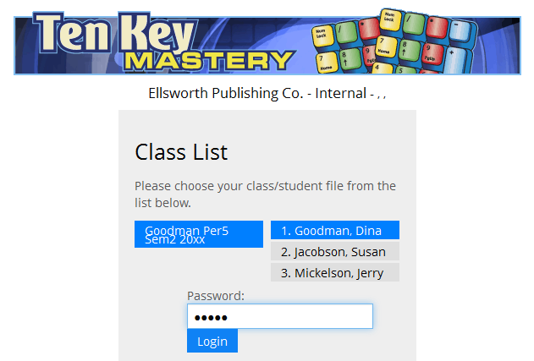

Step Four—Follow along on your computer as you read these step-by-step directions. They will give you a demo of your course

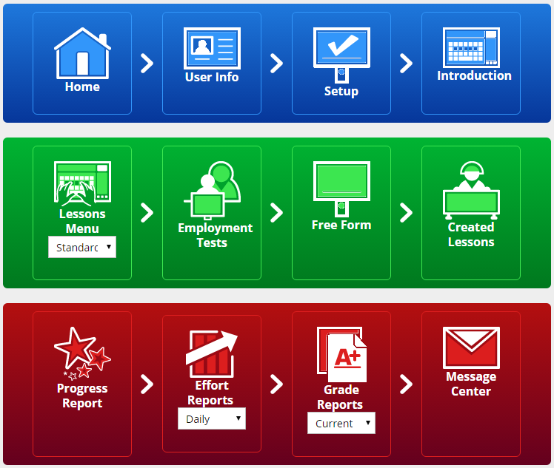

- Click the User Info icon. You may enter your email address and phone number. These will appear on the class report for the instructor. You can change your individual password from the one given by your instructor to a personal password if you wish. (The instructor may lock the password so it can’t be changed.) When through, click “Close” if no changes, or “Save changes”.

- Click the Setup icon. Check the course standards set by your teacher by clicking on the various tabs beginning with Accuracy. You cannot change anything in the Setup. Notice in the Grades tab the speed and accuracy required for an “A” grade. On the Next Step tab, click on the link Click here to visit the Introduction.

- The Introduction is designed to give you practice on the numeric keypad home row, and show you how your score is recorded.
In the blue strip on top of your window, if necessary click the Expand button to see the course options:

- Click the Lessons Menu in the green area. A box appears asking for your Access Code—this is asked for only once. This code is in the back of your textbook, or is the one purchased online or in a college bookstore. After entering the Access Code, you are now into the course software:

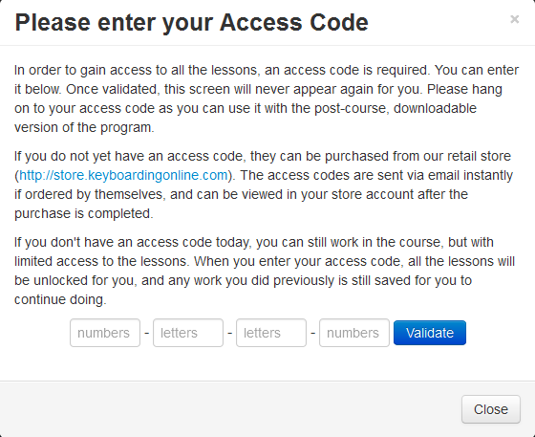
Enter Access Code and click the Validate button
If you don’t have an Access Code yet, click the Close button. A few lessons will show so you can start practicing—probably a week’s worth. It gives you a little extra time to purchase the Access Code.

- Lesson 1—7 4 1 keys are highlighted in the menu on the top left. Lesson 1 shows above the numbers:

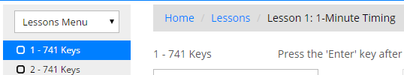
GENERAL INFORMATION:

  - Before you begin, move the Adjust Font Size slider (lower right) to the right to make the numbers larger.

  - There is a faint tab identified as Screen 1. Click below the tab to activate the entry box that will receive the numbers. You will only have to do this once during a session.

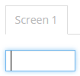

  - The timer will begin when you enter the first number. Enter the number that shows in the blue box and press the Enter key. Follow the blue box and enter the numbers.

  - When you finish one row, keep going to the next row—the numbers of the first row will automatically change. When you are finished with the second row, immediately go to the first row which has new numbers. Continue entering the numbers in the blue box. KEEP GOING UNTIL THE TIMER STOPS YOU!

  - If you know you made a mistake and want to start over without waiting for it to time out, click on the Time Remaining button and it will reset. If you finish a timing and want to take it again, click on the Time Remaining button.

  - Your teacher may have set a timeout to encourage you to keep your eyes on the blue square numbers. If you pause for more than the seconds allowed, the program assumes you are hunting & pecking and will stop the timing. You will have to start over.

PRACTICE LESSON 1 UNTIL YOU REACH YOUR GOAL:

- Lesson 1: 1 – 741 Keys is highlighted in the menu on the left. Two rows of numbers appear with a blue box on the first number.

    - Place your hands on the Home Row (4 5 6) and your little finger touching the Enter key.

    - Enter the first number, 14, and press the Enter key with your little finger. The timer will begin when you depress the first key.

    - When you finish the first column, begin the second column.

    - When you finish the second column, begin again in the first column (which will have changed automatically). If you finish a whole screen, a new one will appear so you can keep entering numbers until the timer stops you.

    - Keep practicing until you reach your goal—there is no limit to the number of times you can practice each lesson.

    - The best 5 speeds of all timings taken, that meet the accuracy rate, will automatically record. The Best Score is used for grading purposes.

NOTES: 1) Your teacher may have turned on a timeout feature—if you pause more than the seconds allowed, your timing will abort and you will have to start over. This is designed to encourage you to keep your eyes on the copy. If you look at the keypad to hunt and peck, you won’t be able to find your way back to continue and your practice timing will abort. Real skill is “by touch”, without looking at the keys or your fingers. 2) Your teacher may have set a “minimum ksph” (key strokes per hour). If your practice timing meets the errors allowed and doesn’t record, your timing probably didn’t meet the minimum ksph. Keep practicing. If it doesn’t meet the Accuracy Rate, it won’t record either. Keep practicing.

- Progress Reports

- Click on Progress Reports, and Simple Report to see the best speeds recorded for each exercise.

If your screen is small, and you can’t see all the sections (Home, Intro, etc.) you might need to click on the expand button to see the menu above:


- Grade Reports

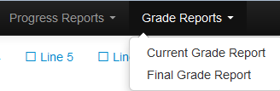

- Click on Grade Reports to see either your Current Grade or Final Grade:

- Select Current Grade Report to see your average score for all completed lessons so far in order to compare it to the grading scale. This is often used as a mid-term grade.

- Select Final Grade Report. A final grade will appear only after all assigned lessons are completed.

IMPORTANT: If you want to raise your grade, go back to your Progress Report and note which scores are lower than your goal. If you right click on the lower score, the program will automatically take you to that lesson and exercise. Practice to raise any lower scores—higher scores on the Progress Report can raise your final grade.

HOW TO SEND A MESSAGE TO YOUR TEACHER

- Click the Home button to get back to the Main Menu above:

- Click on the Message Center icon.

- Click on Send a Message, Create your Message, and click the Send Message button:

END A SESSION PROPERLY

Before exiting the program and/or the Internet, be sure to click “Logout”.

Last Instructions

Be sure to read the instructions carefully. Remember: You do NOT have to turn anything in—I can see your scores and grades online in my Teacher Manager.

Good luck. Let me know if you have any questions: Teacher name.

